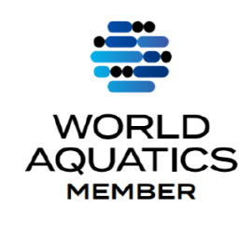

AKUATIK MALAYSIA

(MALAYSIA AQUATICS)

(formerly known as Persekutuan Renang Malaysia/Malaysia Swimming Federation)
Reg. No. K-KUL-00366 TIN No. F 58932212050
#02-03 Aras 3, Pusat Akuatik Nasional. Kuala Lumpur Sports City
Bukit Jalil, 57000 Kuala Lumpur. Tel : +603-8999 4588
Email : secgen@malaysiaaquatics.org Website:www.malaysiaaquatics.org

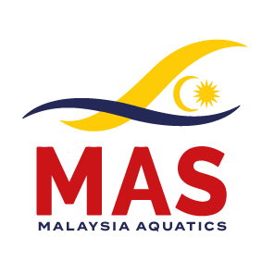

Date: 26 Aug 2025

To:
Presidents/Honorable Secretary,
All MAS State Affiliates.

Dear Sir / Madam,

MILO / MAS MALAYSIA LONG COURSE SWIMMING CHAMPIONSHIPS 2025,
9th -12th October 2025

Malaysia Aquatics is pleased to extend an invitation to all State Affiliates/Clubs/World Aquatics Member Federations to participate in the MILO / MAS MALAYSIA LONG COURSE SWIMMING CHAMPIONSHIPS 2025, which will be held at the National Aquatic Center, Kuala Lumpur Sports City, Bukit Jalil from 9th -12th October 2025

Malaysia Aquatics is pleased to inform that [documents have been submitted for approval to] World Aquatics to act as a Qualifying Event for the World Aquatics Swimming Championships (25m)
2026. On behalf of the Organizing Committee, we would like to welcome your team to Malaysia to participate in this Championships.

The Information Package is attached. Should you require further information, please feel free to contact us by email.

We thank you in advance for your participation and we look forward to receiving your entries as soon as possible.

Yours sincerely,
Malaysia Aquatics
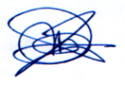
(LOW SIAK SAN, ANDY)
Secretary General

