

AKUATIK MALAYSIA

(MALAYSIA AQUATICS)

(formerly known as Persekutuan Renang Malaysia/Malaysia Swimming Federation)
Reg. No. K-KUL-00366 TIN No. F 58932212050
#02-03 Aras 3, Pusat Akuatik Nasional. Kuala Lumpur Sports City
Bukit Jalil, 57000 Kuala Lumpur. Tel : +603-8999 4588
Email : secgen@malaysiaaquatics.org Website:www.malaysiaaquatics.org

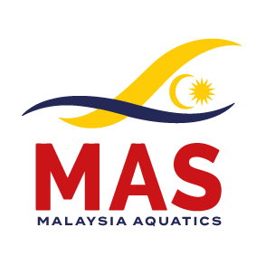

MILO / MAS MALAYSIA LONG COURSE
SWIMMING CHAMPIONSHIPS 2025,
9th -12th October 2025

PRELIMINARY ENTRY FORM
(Please return by 10th September 2025)

1 | Country / Federation:
2 | Contact Person:
3 | Telephone Number:
4 | E-mail:

Yes, we will participate in the 67th MAS / NSC / MILO MALAYSIA OPEN
SWIMMING CHAMPIONSHIPS 2025

 |  | MALE | FEMALE | TOTAL
1 | Number of swimmers:
2 | Number of officials:

1 | Estimate Arrival Date:
2 | Estimate Departure Date:
3 | Estimate No of single rooms:
4 | Estimate No of twin rooms:

___________________________ _____________________ ___________
Name / Signature Designation Date

Please send by E-mail to: Organising Secretary
MILO / MAS MALAYSIA LONG COURSE
SWIMMING CHAMPIONSHIPS 2025
Email – secgen@malaysiaaquatics.org / malaysia.aquatics@gmail.com

