

AKUATIK MALAYSIA

(MALAYSIA AQUATICS)

(formerly known as Persekutuan Renang Malaysia/Malaysia Swimming Federation)
Reg. No. K-KUL-00366 TIN No. F 58932212050
#02-03 Aras 3, Pusat Akuatik Nasional. Kuala Lumpur Sports City
Bukit Jalil, 57000 Kuala Lumpur. Tel : +603-8999 4588
Email : secgen@malaysiaaquatics.org Website:www.malaysiaaquatics.org

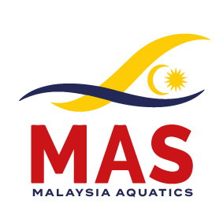

MILO / MAS MALAYSIA LONG COURSE
SWIMMING CHAMPIONSHIPS 2025
9th -12th October 2025
TEAM LIST FORM
(Please return by 24th September 2025)

1 | Country / Federation:
2 | Contact Person:
3 | Telephone Number:
4 | E-mail:
5 | Team manager:
6 | Coaches:
7
8 | Others:
9
10

MALE |  |  | FEMALE
NO. | NAME | DATE OF BIRTH | NO. | NAME | DATE OF BIRTH
MALE |  |  | FEMALE
NO. | NAME | DATE OF BIRTH | NO. | NAME | DATE OF BIRTH

___________________________ _____________________ ___________
Name / Signature Designation Date

Please send by E-mail to: Organising Secretary
MILO / MAS MALAYSIA LONG COURSE
SWIMMING CHAMPIONSHIPS 2025.
Email – secgen@malaysiaaquatics.org / malaysia.aquatics@gmail.com

